Task 8 Output

LS3_avgpool_5_nnmf, k=10, image_id=0

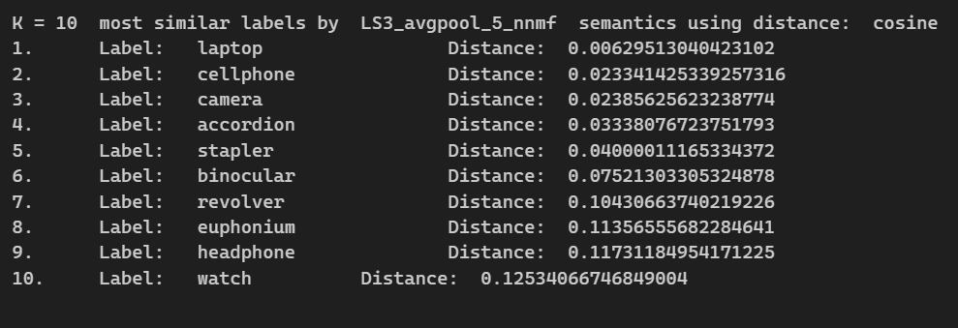

LS3_avgpool_5_nnmf, k=10, image_id=8676

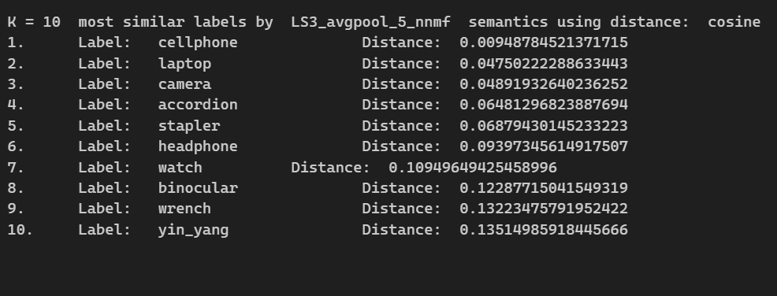

LS4_layer3_5_lda, k=10, image_id=0

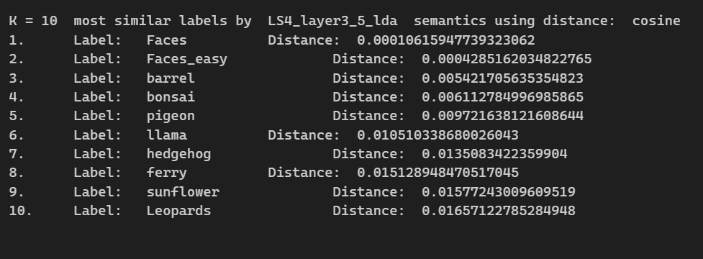

LS4_layer3_5_lda, k=10, image_id=8676

